**Fifth Grade Supply List**

#2 Pencils (no mechanical) (no pencil sharpener)

Colored pencils

Erasers

5 composition notebooks

Graph paper

Notebook paper

1 - 4-inch 3 ring binder with plastic in front and back

Dividers

Glue Sticks

Headphones (No beats, no earbuds or airpods )

Colorful markers

2 pocket plastic folders with prong

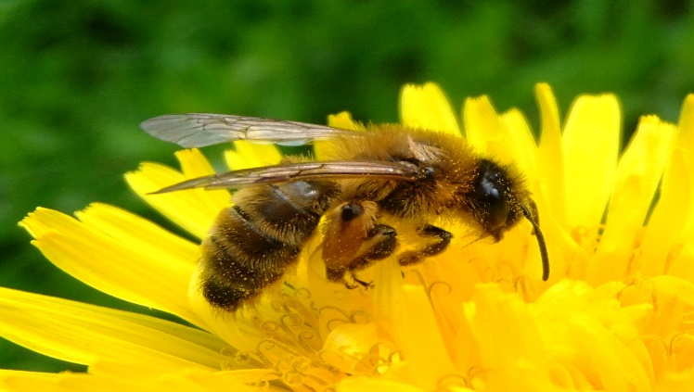

[This Photo](https://commons.wikimedia.org/wiki/File:Honey_bee_on_a_dandelion,_Sandy,_Bedfordshire_(7002893894).jpg) by Unknown Author is licensed under [CC BY-SA](https://creativecommons.org/licenses/by-sa/3.0/)

Please do not label the supplies

**Donations:**

Clorox or Lysol wipes

2 boxes of Kleenex

Ziplock bags – gallon and quart

Individual wrap snacks